**DESIGN AND CONSTRUCTION OF 4-WAY MICROCONTROLLER-BASED TRAFFIC LIGHT CONTROL SYSTEM**

**BY**

**UKPONG Dennis Kenneth**

**(ET/EE/HND/21/069)**

**A PROJECT REPORT SUBMITTED IN PARTIAL FULFILMENT**

**OF THE REQUEMENT FOR THE AWARD OF HIGHER NATIONAL DIPLOMA IN ELECTRICAL AND ELECTRONIC ENGINEERING TECHNOLOGY**

**DEPERTMENT OF ELECTRICAL AND ELECTRONIC ENGINEERING**

**TECHNOLOGY, FEDERAL POLYTECHNIC MUBI.**

**SEPTEMBER, 2023**

# DEDICATION

This project entirely dedicated to the almighty God for his infinite mercy and love in my life and for giving me the wisdom to carry out this research work successfully without much stress and to my lovely parent.

# DECLARATION

I hereby declare that the project work entitled “**Design and Construction of a 4-Way Microcontroller-Based Traffic Light Control System”** was written by me **UKPONG Dennis Kenneth** It is my record of work; The work has not been presented or submitted elsewhere for consideration of degree/diploma/certificate award. All references made to published literatures have been duly acknowledged.

Signature…………………………….. Date………………………………..

**UKPONG Dennis Kenneth**

(ET/EE/HND/21/069)

# CERTIFICATION

This is to certify that this project work “**Design and Construction of a 4-Way Microcontroller-Based Traffic Light Control System”** presented by UKPONG Dennis Kenneth has been written in accordance with regulations governing the preparation and presentation of projects in the Federal polytechnic Mubi and meets the requirements for the award of Higher National Diploma in Electrical and Electronics Engineering Technology.

Signature…………………………….. Date………………………………..

**UKPONG Dennis Kenneth**

(ET/EE/HND/21/069)

Signature…………………………… Date………………………………..

**Engr. Kaigama A. M.**

(Project Supervisor)

# APPROVAL PAGE

This project report entitled “**Design and Construction of a 4-Way Microcontroller-Based Traffic Light Control System”** presented by **UKPONG Dennis Kenneth** was submitted to the Department of Electrical and Electronics Engineering Technology and has been accepted as partial fulfilment of the requirement for the award of Higher National Diploma in Electrical and Electronics Engineering Technology. Federal polytechnic, Mubi.

Signature…………………………… Date……………………………

**Engr. Kaigama A. M.**

(Project Supervisor)

Signature…………………………… Date……………………………

**Engr. Victor O. N.**

(Head of Department)

Signature…………………………… Date……………………………

E**ngr. Muhammad Aliyu Gadam Ph.D**

(External Supervisor)

# ACKNOWLEGMENT

I want to acknowledge Almighty God for his infinite mercy and protection throughout our academic activities. And for the understanding in achieving my academic success.

I also recognize my Supervisor Engr. Kaigama A. M. for his untiring and useful comments, support, guidance and suggestions he provided to critically review the manuscripts to effect the necessary corrections throughout this research work. I am very happy to acknowledge his zealous efforts.

My sincere appreciations and thanks goes to the Head of Department Engr. Victor Nkeleme O. for his moral encouragement throughout my period of study. I also acknowledge all Staff of Electrical Electronics Engineering Technology, Federal Polytechnic, Mubi for all their sacrificial commitments in the process of imparting academic knowledge on me.

I wish to extend my hearty acknowledgment of gratitude to my lovely parent and my entire family members.

Finally, I appreciate the efforts of my friends and relatives, course mates and all well-wishers. I love you all, may the Almighty God bless you abundantly, Amen.

# ABSTRACT

*This project work is on construction of an Arduino based traffic light system. A 3-way traffic light signaling device positioned at 3-way road intersections, pedestrian crossings and other locations to control competing flows of traffic. The road construction safety traffic light system designed to replace a manual traffic control on a road construction site. This device can replace one or both flaggers during the two-lane closures on the event of a road construction. The road construction safety traffic light system is considered one of the best device in work zone traffic flow control system. The device is a portable traffic light unit which can be best utilized in controlling traffic flow in a road construction site for long term or short term lane closures and to control two-way traffic in a single lane. By implementing new technologies in automating traffic flow in road construction site could possibly eliminate the usage of a conventional flagman at all times. The construction is made of electronic component both active and passive. The construction was done and the aimed of the construction was achieved this project write up is from chapter one to five each discussed on a related work.*

# TABLE OF CONTENT

Contents page

TITLE PAGE i

DEDICATION ii

DECLARATION iii

CERTIFICATION iv

APPROVAL v

ACKNOWLEGMENT vi

ABSTRACT vii

TABLE OF CONTENT viii

LIST OF TABLES x

LIST OF FIGUERS xi

CHAPTER ONE 1

INTRODUCTION 1

1.1 Background of the Study 1

1.2 Statement of the Problem 2

1.3 Aim and Objectives of the Study 2

1.4 Significance of the Study 3

1.5 Scope of the Study 4

CHAPTER TWO 5

LITEARTURE REVIEW 5

2.1 Related Work 5

2.2 Theoretical Review 10

2.2.1 Traffic Control System 10

2.1.2 Air Traffic Control 10

2.2.2 Train Approach Signals 11

2.2.3 Automatic Traffic Control System 11

2.2.4 4-Way Traffic Light System 12

CHAPTER THREE 13

SYSTEM DESIGN AND ANALYSIS 13

3.1 Block Diagram 13

3.2 System Sections 14

3.2.1 Power Supply 14

3.2.2 The Microcontroller 15

3.2.3 The Indictors 16

3.2.4 Software Design Analysis 18

3.2.4.1 Flow Chart 18

3.2.4.2 Software System Section 19

3.3 System Construction 19

3.3.1 Components List 19

3.3.2 Components Layout 19

3.3.3 Components Soldering 20

3.3.4 Casing/Packaging 21

3.4 Principle of Operation 21

CHAPTER FOUR 24

TESTING, RESULTS AND DISCUSSION 24

4.1 Testing 24

4.1.1 Sectional Circuit Testing 24

4.1.2 Prototype Testing 24

4.2 Result 25

4.3 Discussion 26

4.4 BEME Table 27

CHAPTER FIVE 28

SUMMARY, CONCLUSION AND RECOMMENDATIONS 28

5.1 Summary 28

5.2 Conclusion 28

5.3 Recommendations 29

REFERENCE 30

# LIST OF TABLES

**TABLE Page**

Table 3.1: Component List……………………………………………………………….. 19

Table 4.1: Sectional test result………………….………………………………………….. 25

Table 4.2: Performance test result………………………………..…………..…………….. 26

Table 4.3: BEME Table…………………………………………………...……………….. 27

# LIST OF FIGUERS

# FIGURE Page

Figure 3.1: Block diagram of the four-way traffic control system………………………… 13

Plate 3.1: The battery type…………………………………………….....………………… 14

Figure 3.2: The Arduino Nano…………………………………………...………………… 16

Figure 3.3a: LED structure……………………………..…………….....………………… 17

Figure 3.3b: LED types………………………………………..………....………………… 18

Figure 3.4: Flowchart…………………………………..………..…….....………………… 18

Plate 3.2: Component layout……………………….………………….....………………… 20

Plate 3.3: Casing of 4-way traffic light……………………………………..……………… 21

Figure 3.5: Bread boarding of a 4-way traffic light circuit………………………………… 23

Figure 3.6: Schematic diagram of 4-way traffic light circuit……………………………… 23

# CHAPTER ONE

# INTRODUCTION

## 1.1 Background of the Study

The world first traffic light come into being before the automobile was in use and traffic consisted only of pedestrian, buggies and wagon, installed in an intersection in London in 1968 it was a revolving lantern with red and green signals, red means “stop” and green means “caution” the lantern illuminated by gas was turned by means of a lever at it base so that the appropriate light faced traffic, on January 2, 1869, this crude traffic light exploded, injuring the policeman who was operating it (Carter, 2018).

After the coming of automobiles, the situation got even worse, policer William L. Potts of Detroit, Michigan decided to do something about the problem, what he had in mind was figuring out a way to adapt railroads were already utilizing automatic controls, but railroad traffic traveled along parallel lines, street light traveled at right angles, Potts used red, and green railroad lights and about thirty seven dollar worth of wire and electrical control to make the world’s first 4-way three color traffic light, it was installed in 1920 on the corner of Woodward and Michigan avenues in Detroit, within a year, Detroit had installed a total of fifteen of the new automatic lights. At about the same time Garrett Morgan of Cleveland, Ohio realized the need to control the flow of traffic. A gifted inventor and reportedly the first African American to own an automobile in Cleveland, Ohio, he invented the traffic electric automatic traffic light, though it looked more like the semaphore signals you see at train crossing today (Graham, 2019).

## 1.2 Statement of The Problem

Traffic management is a critical aspect of urban infrastructure, and efficient traffic control systems play a pivotal role in ensuring safe and orderly vehicular movement. Traditional traffic light systems, while effective, often lack adaptability and smart control features that can respond dynamically to varying traffic conditions. This creates challenges such as unnecessary traffic congestion, inefficient use of road space, and increased travel time for commuters.

To address these challenges, there is a pressing need for the design and construction of a 4-Way Microcontroller-Based Traffic Light system that can intelligently regulate traffic flow at intersections. The existing traffic light systems suffer from limitations, including fixed-time control, which does not adapt to real-time traffic demands. These limitations lead to inefficiencies, increased fuel consumption, and environmental concerns.

## 1.3 Aim and Objectives of The Study

The aim of the project is to construct an Arduino based four-way traffic light using three colors LED red, yellow and green in order to reduce crossing road accident.

1. To design the microcontroller interface for the traffic light
2. To design the colored LED lighting section of the traffic light.
3. To construct and test the designed system

## 1.4 Significance of The Study

The significance of the study on the "Design and Construction of a 4-Way Microcontroller-Based Traffic Light" is multifaceted and encompasses various aspects that contribute to the improvement of urban traffic management and road safety. Here are the key points highlighting the significance of this study:

Enhanced Traffic Flow: The implementation of a microcontroller-based traffic light system with adaptive control can significantly improve traffic flow at intersections. This leads to reduced congestion, shorter travel times, and improved overall road network efficiency, benefiting both commuters and the environment.

Reduced Traffic Congestion: Traffic congestion is a major issue in urban areas, leading to wasted time, increased fuel consumption, and higher levels of air pollution. By optimizing traffic signal timings based on real-time conditions, this study can help mitigate congestion, reducing its adverse effects on the environment and quality of life.

Energy Efficiency: The use of LED lights and energy-efficient microcontroller technology ensures that the traffic light system operates with minimal power consumption. This contributes to reduced energy costs and a smaller carbon footprint, aligning with sustainability goals and environmental conservation.

Pedestrian Safety: Implementing pedestrian-friendly features, such as countdown timers and safe crossing intervals, enhances pedestrian safety at intersections. This is crucial for protecting vulnerable road users, such as pedestrians and cyclists, and reducing accidents.

Emergency Vehicle Priority: The ability to prioritize emergency vehicles through intersections can be a lifesaving feature. By allowing rapid passage of ambulances, fire trucks, and police vehicles, this study supports emergency response efforts and potentially saves lives in critical situations.

## 1.5 Scope of The Study

The project presents a concise work and study intended to solve problem of road usage for a 4-way only. The Red, Yellow and Green flash from the bulb at each phase of the junction signifies stop, get ready, and go, instruction respectively. Using Arduino microcontroller and other active/passive components.

# CHAPTER TWO

# LITEARTURE REVIEW

## 2.1 Related Work

The construction of an Arduino based 4-way traffic light control system uses of traffic controlling devices, this controlling device includes a regulatory color with different light bulbs of different colors with different instruction attached to them. Carter (2016), suggested that after the achievement of the traffic controlling system, not to be left out in traffic engineering, which is one of the important aspects of higher engineering since it greatly aids in resolving problems encountered in road trafficking.

Developing countries employ human being to regulate traffic. In the modern technology, automatic operated traffic control system is used. With the use of this electronic traffic light control system, the deficiencies discovered with the use of man as a traffic warder have been greatly eliminated. The construction of this project 4-way Traffic Light Control System, was initiated as a result for controlling vehicle operation in the traffic stream. It is the common form of signal control and result in inappropriate behavior in traffic which differs from that which the plan was based.

Rongrong (2013), suggested the use of TRANSYT traffic modeling software to find the optimal fixed-time signal plan and VISSIM micro-simulation software to affirm and evaluation of the TRANSYT model and to help assess the optimal signal plan; build an adaptive frame signal plan and refined and evaluated the plan using VISSIM with VS-PLUS emulator. Micro-simulation, show that delay in the adaptive signal control was shortened noticeably than that in the fixed time control.

Jianhua *et al.* (2017), introduced a new method for area-wide traffic signal timing optimization under user equilibrium traffic. The optimization model was formulated as a multi-dimensional search problem aimed to achieve minimized product of the total travel time associated with urban street network and the variance of travel time for unit distance of travel. A genetic algorithm was developed to derive the model solution. A simulation control protocol embedded in PARAMICS software tool capable of conducting area-wide micro simulation is adopted to design the logic frame and function module of the area-wide traffic signal control system. His results shown that mobility improvements are achieved after applying the proposed model along with the genetic algorithm for area-wide signal timing optimization, assessed by extended capacity ratio, and reductions in through and turning movement delays, as well as average and variance of travel time for unit distance of

travel.

Gustav (2014), focused on a class of dynamic feedback traffic signal control policies that are based on a generalized proportional allocation rule. There results in a differential inclusion for which there prove existence and, in the special case of orthogonal phases, uniqueness of continuous solutions via a generalization of the reflection principle. Stability is then proved by interpreting the generalized proportional allocation controllers as minimizes of a certain entropy-like function that is then used as a Lyapunov function for the closed-loop system.

Junchen (2018), proposed a group-based signal control approach capable of making decisions based on its understanding of traffic conditions at the intersection level. The control problem is formulated using a framework of stochastic optimal control for multi-agent system in which each signal group is modeled as an intelligent agent. The proposed system is designated to be compatible with the prevailing signal system. The parameters were off-line optimized using a genetic algorithm. Simulation results shown that the proposed adaptive group-based control system outperforms the optimized GBVA control system mainly because of that’s real-time adaptive learning capacity in response to the changes in traffic demand.

Nasser *et al*. (2011), controlled the movement of traffic on urban streets by determining the appropriate signal timing settings. The proposed algorithm was based on the so-called memetic algorithm that combines the strengths of the genetic algorithm and local search in an adaptive manner. In that used two important techniques for improving the performance of traditional memetic algorithms. First, a systematic neighborhood based simple descent algorithm was employed as a local search to effectively exploit the search space. Second, an indicator scheme was proposed to control the local search application based on the quality and diversity of the search process. The proposed algorithm was coded in the commercial microscopic traffic simulator, AIMSUN, and tested on two difference real world case studies in Brisbane,Australia, and Plock, Poland. The results demonstrated that the proposed algorithm was better than genetic algorithms and fixed-time settings, indicated that the proposed algorithm was an effective solution method for traffic signal optimization problems.

Mohammad *et al*. (2019), utilized Reinforcement Learning (RL), algorithms to design adaptive traffic signal controllers called actor-critic adaptive traffic signal controllers (A-CATs controllers). Worked done rested on the integration of three threads: (a) shows performance compared of both discrete and continuous A-CATs controllers in a traffic network with recurred congestion (24-h traffic demand) in the upper downtown core of Tehran city, (b) analysed the effects of different traffic disruptions included opportunistic pedestrians crossing, parking lane, non-recurring congestion, and different levels of sensor noise on the performance of A-CATS controllers, and (c) compared the performance of different function approximators (tile coding and radial basis function) on the learning of A-CATs controllers. First an agentbased traffic simulation of the study area was carried out. Then six different scenarios are conducted to find the best A-CATs controller that was robust enough against different traffic disruptions. They observed that the A-CATs controller based on radial basis function networks (RBF (5)) outperforms others. They said that RBF (5) was benchmarked against controllers of discrete state Qlearning, Bayesian Q-learning, fixed time and actuated controllers; and the results revealed that (RBF (5)) consistently outperforms others.

Huajun (2015), captured the interaction between travellers’ route choice and traffic signal control in a coherent framework. They tested their algorithm and control strategy by simulation in OmNet++ (A network communication simulator) and SUMO (Simulation of Urban Mobility) under several scenarios. The simulation results shown that with the proposed dynamic routing, the overall travel cost significantly decreases. It was also show that the proposed adaptive signal control reduced the average delay effectively, as well as the fluctuation of the average speed within the whole network.

Ekinhan (2016) suggested a new method for designing traffic signal timing at oversaturated intersections and was expressed as “the elimination pairing system”. An object function with vehicle delay and stop-start numbers has been generated, total cost value has been calculated according to the object function, obtained results were compared with Webster as a traditional traffic signal timing design method and Transyt 14 signal timing software, while Webster gives exaggerated results, Transyt 14 and Elimination Pairing Systems provided better results. As a result of that study, the elimination pairing system could be used for optimizing the traffic signal timings.

Shailendra (2016), developed a new lane bypass algorithm for route diversion given a result in smooth traffic flow on the urban road network. Genetic algorithms are utilized for the parameter optimization.

Ishant (2006), proposed a model to replace the existing traffic signals with a system that monitors the traffic flow automatically in traffic signal and sensors are fixed so that the time feeds are made dynamic and automatic by processing the live

detection.

Chandrasekhar (2012), suggested a system that implement image processing algorithm in real time traffic light control which will control the traffic light efficiently.

Ramteke (2012), proposed FPGA (Field Programmable Gate Array) controller based on Neuro-Fuzzy system thought provided effective solution for Traffic Control. It can have used to minimize drawbacks of the conventional traffic controllers with the accuracy of provided variation in green cycle intervals based on the heavy traffic loads that changed at every lane in a four leg intersection.

Naren (2010), introduced an adaptive predictive signal control system that performed real time queue length estimation and employed an efficient signal coordination algorithm with APTTCA-based system.

Pavan (2017), studied adaptive traffic control systems with Vehicular Ad Hoc Network (VANET), focused on reliable traffic prediction approaches and various types of adaptive traffic control algorithms also proposed a mobile crowd sensing technology to support dynamic route choices for drivers to avoid congestion. Suggested crowd sourcing can be one of the best options for Adaptive traffic control system for India.

Jayesh (2018), described various soft computing techniques to tackle traffic control system adopting fuzzy approaches, neural network and genetic algorithms, ant colony algorithm, particle swarm optimization, simulation model.

## 2.2 Theoretical Review

The design and construction of a 4-Way Microcontroller-Based Traffic Light system draw upon several key theoretical principles and concepts from the fields of traffic engineering, control theory, and microcontroller technology.

### 2.2.1 Traffic Control System

The traffic light system used in most urban areas for controlling traffic is a common example of traffic system controlling vehicular movement such as airplanes, trains, automobile and even pedestrians. Traffic control system ensure safe and orderly movement off airplane at airports during periods of heavy traffic. They also provide efficient movement along rails; cars from one point to another, reduce congestion and also provide smooth flow of traffic along busy roads metropolitan area.

The responsiveness of the vehicle operator, the nature of the vehicle, severity of the traffic problem and requirement placed upon the traffic control system all determine the nature and complexity of the traffic control system.

### 2.1.2 Air Traffic Control

With the increasing speed and volume of aircraft, it is necessary to provide traffic control to avoid collision in the air or on the ground to guide aircraft for safe landing and release them for timely take – off.

All these are carried out with the help of the reroute control and the terminal control. Under the reroute control, control of an airplane flying under Instrument flight rules begins when the pilot flies with the Air Route Traffic Control Center (ARTCC), a flight plan indicating estimate departure time, fight route, attitude and destination. While in the terminal control, the airport traffic control tower (ATCT) con troll all take – off and landing operations, departure, approach operation and ground movement of aircraft and airport vehicles.

This is accomplished by guidance facilities consisting of instrument landing system approach lighting, very high frequency Omni-range, various riders and multiple air-ground communication channels (Watson, 2019).

### 2.2.2 Train Approach Signals

Traffic is sometimes controlled at a railed way road junction to warn user of an approaching train. This traffic control is normally done by;

1. **Flash Light:** With this method control, flashing red ‘stop’ light warns the road user of an on – coming train. The flashing red ‘stop’ signals may be electrically or mechanically controlled (Douglas, 2017).
2. **Wig – Wag Signals:** This is quite similar to the flashing light methods except for the fact that a swimming disc with a red light enclose in it is used to give signal that a train is approaching (Hontwritz & Hill, 2016).

### 2.2.3 Automatic Traffic Control System

A traffic light system is the basis circuit used in automobile traffic control systems. It is a system that controls or regulates the movement of automobiles.

The system is meant to operate at a point where automobile from different approaches of the roads met to change direction of movement. The road approaches could be of 5-ways, 4-ways or 3- ways junction. In this case, a 3-way or T–Junction with a roundabout constructed within the junction is considered (Boylestad & Washisky, 2005).

### 2.2.4 4-Way Traffic Light System

Intersection influence the movement and safety of traffic flow so much that the study of their characteristics is important. Road users mutually adjust their preference in order to avoid conclusion with each other.

The circuits have been constructed to have an output of light flash contained in water light with the partitions. Each bulb is placed in a partition in the flowing by amber (yellow) and the green bulb at the bottom.

1. The red light means ‘stop’ and wait behind the stop line on the carriage-way.
2. Amber (yellow) means ‘get ready to go’.
3. Green light means you may go only if the maybe is car.

The pad sense the movement, and thus send out and appropriate signal to the controller, which execute the necessary logic for the required green time.

This project is being designed and constructed so that the lighting box is installed at a site within the junction in such a way that It could be properly visualized by the users of the road.

Project is aim to solving the problem of accident casualties involving passer –by and users of mobile and automobile system such as cars, motorcycles, bicycles truck pusher etc. Such user of road will only benefit if instruction is strictly adhered to (Obeyed). It will go a long way in greatly reducing or minimizing road accidents (Graham, 1991).

# CHAPTER THREE

# SYSTEM DESIGN AND ANALYSIS

## 3.1 Block Diagram

The system is made up of several blocks as given in the block diagram on Figure 3.1.

Power Supply

Microcontroller

LED Output

*Figure 3.1: Block diagram of the four-way traffic control system.*

The system consists of three basic blocks, the power supply, the microcontroller and the indicators.

The power supply is a 9V PP3 type dry cell to offer bias to the whole system. The microcontroller is the heart of the system which is programmed to cause the LEDs to light up at the right order and timing. While the indicators or LEDs convert the electrical signal from the microcontroller to light at different colours.

## 3.2 System Sections

### 3.2.1 Power Supply

A power supply is defined as a unit that supplies electrical power to another unit. It is one of the most important sub-systems in any electronic system. They are of different type, proper selection of the suitable type of a particular system is very important. It is an affordable, reliable, dedicated low-power solution to provide sufficient energy to your application. Ideally used in circuits with low power consumption so that it can work for longer durations.

This battery is a high capacity & low cost solution for many electronic devices. It is used with its specific battery snap, connector or clip. Sealed in original package Model : 6F22M System : Zinc Carbon Nominal Voltage(V) :9V Discharge Resistance(Ω): 620 Cut-off Voltage(V): 5.4 DISCHARGE TIME:270HM,9HOURS Jacket: Metal Operating Temperature Range : (deg. C)** -20 to +85 Weight : (g)*** 2.0 Dimensions : 26. 5 H x 48. 5 W x 17. 5 L (mm) CERTIFICATION:ULCEROHSISO9001~2000 * Nominal capacity indicates duration until the voltage drops down, when discharged at a nominal discharge current at 20 deg. C. ** When using these batteries at temperatures outside the range of 0 to +40 deg.

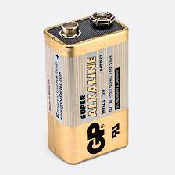

*Plate 3.1: The battery type*

### 3.2.2 The Microcontroller

The main component in this design is the microcontroller with the coordination and control function. The microcontroller chosen for the work is the Arduino nano. Arduino Nano is a small, complete, and breadboard-friendly board based on the ATmega328 (Arduino Nano 3.x).

The Arduino Nano can be powered via the Mini-B USB connection, 6-20V unregulated external power supply (pin 30), or 5V regulated external power supply (pin 27). The Arduino microcontroller was used in this design because of the relative ease of programming and also because of its teaming community available online

Memory

The ATmega328 has 32 KB, (also with 2 KB used for the bootloader. The ATmega328 has 2 KB of SRAM and 1 KB of EEPROM.

Input and Output

Each of the 14 digital pins on the Nano can be used as an input or output, using pinMode(), digitalWrite(), and digitalRead() functions. They operate at 5 volts. Each pin can provide or receive a maximum of 40 mA and has an internal pull-up resistor (disconnected by default) of 20-50 kOhms. (ATmega datasheet, 2010). Serial: 0 (RX) and 1 (TX). Used to receive (RX) and transmit (TX) TTL serial data. These pins are connected to the corresponding pins of the FTDI USB-to-TTL Serial chip. External Interrupts: 2 and 3 shown in Figure 3.2 (Coup, 2012).

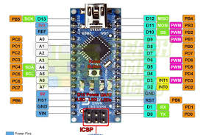

*Figure 3.2: The Arduino Nano*

### 3.2.3 The Indictors

A light-emitting diode is a two-lead semiconductor light source. It is a p–n junction diode that emits light when activated. When a suitable voltage is applied to the leads, electrons are able to recombine with electron holes within the device, releasing energy in the form of photons. This effect is called electroluminescence, and the color of the light (corresponding to the energy of the photon) is determined by the energy band gap of the semiconductor. The material used in LEDs is basically aluminum-gallium-arsenide (AlGaAs). In its original state, the atoms of this material are strongly bonded. Without free electrons, conduction of electricity becomes impossible here. By adding an impurity, which is known as doping, extra atoms are introduced, effectively disturbing the balance of the material. These impurities in the form of additional atoms are able either to provide free electrons (N-type) into the system or suck out some of the already existing electrons from the atoms (P-Type) creating “holes” in the atomic orbits. In both ways the material is rendered more conductive. Thus, in the influence of an electric current in N-type of material, the electrons are able to travel from anode (positive) to the cathode (negative) and vice versa in the P-type of material.

Advantages of LEDs:

i. Very low voltage and current are enough to drive the LED. Voltage range – 1 to 2 volts. Current – 5 to 20 milliamperes. The structure of LED is illustrated in Figure 3.3a and Figure 3.3b.

ii. Total power output will be less than 150 milliwatts.

iii. The response time is very less – only about 10 nanoseconds.

iv. The device does not need any heating and warm up time.

v. Miniature in size and hence lightweight.

vi. Have a rugged construction and hence can withstand shock and vibrations.

vii. An LED has a lifespan of more than 20 years.

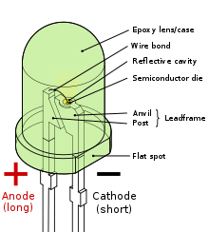

*Figure 3.3a: LED structure*

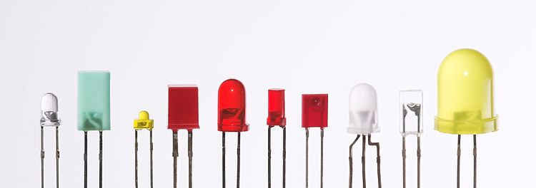

*Figure 3.3b: LED types*

### 3.2.4 Software Design Analysis

### 3.2.4.1 Flow Chart

The program is written based on the deign flowchart shown in Figure 3.4

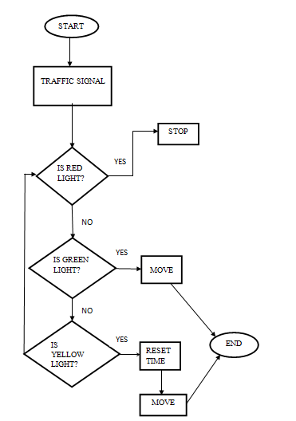

*Figure 3.4: Flowchart*

### 3.2.4.2 Software System Section

To instruct the Arduino microcontroller to put on the colored lights in sequence, the following codes written in C++ are necessary.

## 3.3 System Construction

It is hardly ever possible for anyone to proceed straight from circuits drawing to a scientifically made case and chassis. It is for this reason that the usage of the breadboard has become common for the hard ware implementation of the circuit diagram. Bread board allows the flexibility of components layouts without the about of mental work.

### 3.3.1 Components List

Components that are involved in realizing the project are given in Table 3.1 below.

Table 3.1: Component List

|  |  |  |  |
| --- | --- | --- | --- |
| S/N | Component | Type | Quantity |
| 1 | Microcontroller | Arduino Nano (ATmega328) | 1 |
| 2 | 9V battery | PP3 | 1 |
| 3 | Resistor | 1k | 4 |
| 4 | LED | Red, Green, Yellow | 12 |

### 3.3.2 Components Layout

The components are laid down on the protoboard based on their actual connections on the circuit diagram. The layout is given in Plate 3.2.

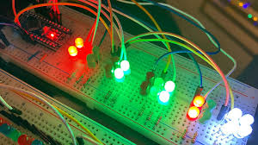

*Plate 3.2: Component layout*

### 3.3.3 Components Soldering

A Vero board is a printed circuit with predrilled holes for ICs and other components but with no inter-connections load on the board itself rather length of insulated wires are used for wiring.

The major consideration in assembling the components on the Vero board was to obtain a neat layout that will make the best use of the board as well as to ensure easy accessibility to each component.

Soldering was done with 15w soldering iron with a pointed copper tip. The soldering lead used had flux in it so that all that was required was to apply the soldering iron to the terminal to be soldered and then put the solder that melts and flows around the joints, care was taken not to apply the iron for more than 10 seconds at a time too any device to avoid damage.

A solder sucker was used to remove unwanted lead or to correct errors, while an engineering knife was employed in cutting unwanted tracks. After soldering was completed, a side cutter was used to snip off excess terminals neat and tidy finishing.

### 3.3.4 Casing/Packaging

After assembling the circuit on Vero board, the next step as to provide some form of housing for it. The main purpose is casing of the device is meant to serve for:

1. Mechanical support
2. Protection of the more delicate parts of the circuit
3. More also aesthetical beauty is also put into considerations with regards to the minimum size and weight of the entire case.

The housing was drawn to size, the rough prototype is shown in Plate 3.3.

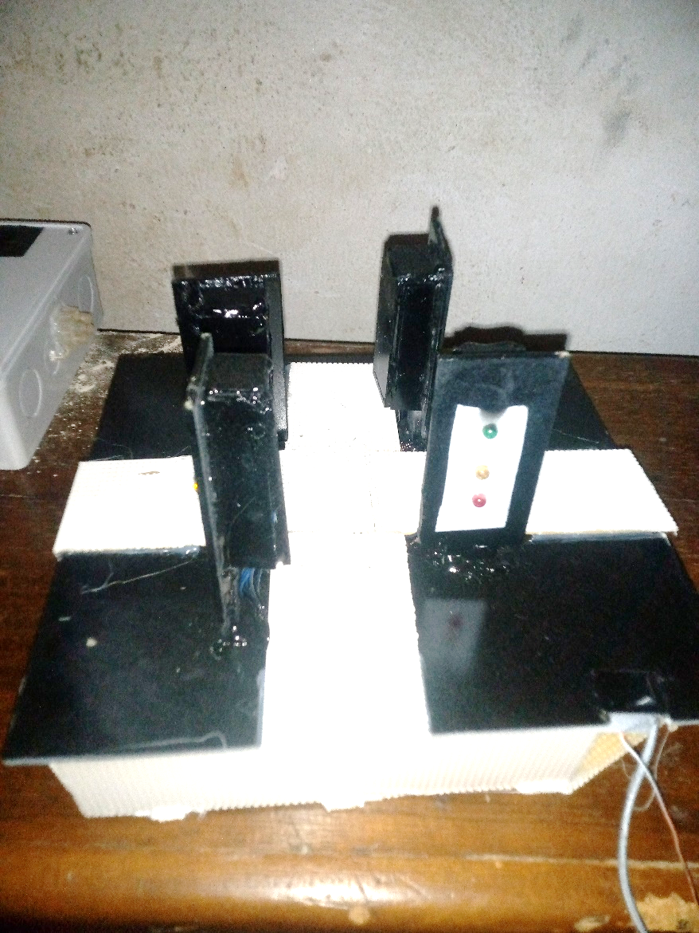

*Plate 3.3: Casing of 4-way traffic light*

## 3.4 Principle of Operation

The real time traffic light controller is a complex piece of equipment which consists of power cabinet, main controller and displays. In this project, a simple traffic light system for a 4 way intersection is implemented using Arduino microcontroller. It gives an idea of the process behind the traffic light control system Consider the following gif image showing a loop of traffic light operations. The project is also implemented in the same manner.

In that, first the Lane 1 gets its Green light turned. Hence, in all the other Lanes, their corresponding Red lights are turned on. After a time, delay of predefined time says 5 seconds, the Green light in the Lane 3 must be turned on and the Green light in the Lane 1 must be turned off.

As a warning indicator, the Yellow light in Lane 1 is tuned on indicating that the red light is about to light up. Similarly, the yellow light in the Lane 3 is also turned as an indication that the green light about to be turned on.

The yellow lights in Lanes 1 and 3 are turned for a small duration say 2 seconds after with the red light in the Lane 1 is turned on and green light in Lane 3 is also turned on.

The green light in Lane 3 is also turned on for a predefined time and the process moves forward to Lane 4 and finally Lane 2.

The system then loops back to Lane 1 where the process mentioned above will be repeated all over again.

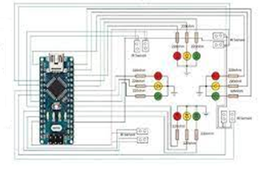

*Figure 3.5: Bread boarding of a 4-way traffic light circuit*

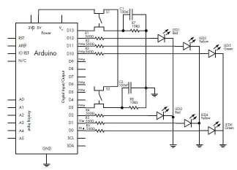

*Figure 3.6: Schematic diagram of 4-way traffic light circuit*

# CHAPTER FOUR

# TESTING, RESULTS AND DISCUSSION

## 4.1 Testing

In order to achieve the objectives of the project four-way traffic light, several hardware components and software tools are employed and used after they have been selected among other alternatives due to some reasons and circumstances. In this section, the prototype system is tested to determine the status of the components used and the operational status of the constructed project.

### 4.1.1 Sectional Circuit Testing

The circuit component was tested one after the other to make sure they are in good working condition before they were mounted on the strip board and was also tested base on the circuit diagram before soldering.

### 4.1.2 Prototype Testing

The project was subjected to tests at the end of the construction although the first test way done on a solders board (bread board) before proper soldering.

A test was also conducted at the end of the construction to ensure proper and efficient function of the system. In confirmation, phase 1, 2 and 3 indicates yellow, red and green respectively for a period of 15 seconds and then the other two followed sequence as designed. The performance evaluation of the traffic system was carried out. The model testing was performed at different occasions of light changing and the result below was achieved.

Initial time of operation of all the lanes = 2 seconds Amber duration = 3 seconds.

Red duration = 8 seconds Green duration = 4 seconds 1 = On

0 = Off

## 4.2 Result

The project was constructed on Vero board, in which the size of the main panel board was used to choose the dimension of the casing used. Many considerations were put in place in form of the procedure and instruction, which led to the successful completion of the project.

Table 4.1: Sectional test result

|  |  |  |  |  |
| --- | --- | --- | --- | --- |
| **S/N** | **Test points** | **Test tool** | **Result** | **COMMENT** |
| 1 | Transformer | Ohmmeter | Prim Coil =1.5k  Sec Coil= 150Ω | OK |
| 2 | Resistor | ohmmeter | All within +/- 5% | OK |
| 3 | Switches | Continuity | continuous when pressed | OK |
| 4 | LEDs | Diode tests | Vf = all >=0.7V | OK |

Table 4.2: Performance test result

|  |  |  |  |  |  |
| --- | --- | --- | --- | --- | --- |
| **Colour** | **Infrared sensor timing** | **North** | **East** | **South** | **West** |
| Red | 8 seconds | 1 | 0 | 1 | 0 |
| Amber/Yellow | 3 seconds | 1 | 1 | 1 | 1 |
| Green | 4 seconds | 0 | 1 | 0 | 1 |

## 4.3 Discussion

The result of the test given in Table 4.1 show that the battery before operation commence is full and of the correct terminal potential of 9V as shown or stated in the design section. Also, the switch is functional as it gives continuity whenever it is closed implying that when in operation it can effectively switch the circuit ON and OFF. It also shows that the connection of the circuit is correct and that the components are not faulty. All voltage levels conform with the expected value from the design, it also means that there are no short circuits or open circuits. The results on Table 4.2 show that the design and construction of a Prototype traffic light control system for crossroad was developed with the following results.

1. Automatic on and off operation of traffic light.
2. Increment assignment to the busiest lane.

From which it can be deduced that the Initial time of operation of all the lanes = 2 seconds Amber duration = 3 seconds. Red duration = 8 seconds Green duration = 4 seconds 1 = On

0 = Off, from which it is evident that the system is truly functioning as a four-way traffic light system.

## 4.4 BEME Table

The completed work is costed to complete the engineering documentation for future decisions. The table of cost estimate or BEME is give n in table 4.3.

Table 4.3: BEME Table

|  |  |  |  |  |
| --- | --- | --- | --- | --- |
| **S/N** | **Component** | **Unit Cost (N)** | **Quantity** | **Amount (N)** |
| 1 | Arduino nano microcontroller | 6000 | 1 | 6000 |
| 2 | Fixed resistor | 100 | 4 | 400 |
| 3 | Battery (9v) | 400 | 1 | 400 |
| 4 | Light Emitting Diode (Red, Green, Yellow) | 100 | 12 | 1200 |
|  |  |  | Total (**N**) = | 9,000 |

# CHAPTER FIVE

# SUMMARY, CONCLUSION AND RECOMMENDATIONS

## 5.1 Summary

This section of this project forms the conclusion part of the write up and take a look at some of the problem encountered during the progressive job of the system.

The construction and development of this project has really been challenging, as we have been face with choice far beyond what we expected, but in the long run the result paid off and the project was successful, despite the short period of time.

## 5.2 Conclusion

In conclusion, it is pertinent to state that despite all the hitches arising from the unavailability of components and materials and technological drawbacks, the design and construction of this four-way traffic light control was successfully realized. And as a matter of fact, since we are in a technological advancing world, It is strongly believe that it takes nothing less than pure determination and the ability to respond to such changes to survive in the present rapidly improving standards of the world system. So being aware of all these challenges, special effort was made to examine the technological problems encountered and also made additional modification in order to enhance the services of this design. The traffic light has been introduced constructed implemented and tested with the output found complying with the expectation and purpose of the project the project was tested at both the stages Red, Yellow and Green each confirm the device reliability the traffic light uses. Automatic traffic lighting system is useful equipment for controlling traffic flow at junctions.

This method has for long outweighed1 the older system in many ways it is more efficient and effective as well, as it can enhance the transportation system of the country saving many hours usually lost in traffic problems. Accidents may also be prevented and lives can be saved

## 5.3 Recommendations

Automatic traffic light control system a useful equipment for controlling traffic at the junctions. More attention should be given to automatic traffic light system by the government, individuals and even drivers as is posed to reducing or preventing road accidents thereby reducing or preventing loss of live associated with it.

1. The government should endeavor to encourage the installation of this system of traffic at necessary junctions in order to reduce the number of accounts associated with road.
2. Drivers and pedestrians should also learn to abide by the rules associated with the system so as to ease traffic congestion and avoid unnecessary stress on the road and fear of crossing intersections by the pedestrians.
3. Higher institution of learning most especially engineering fields should devote time and resources to the project as it would be of great benefit to students and researchers.
4. It is our belief that a greater design can be achieved if standard equipment, materials and components are used. We could not fail to commend that this design still stands much room for improvement.
5. Finally, we will like to suggest that the time limit for the project is not enough, because project construction need enough time.

# REFERENCE

Boylestad, L. & Washisky, L. (2005). *Electrical device and circuit theory*, 8th edition, prentice Hall of India limited, India.

Carter, O. (2016). The burean of public road of the U. S. Department of Transportation.

Douglas, R. (2017). *Fundamental of electronics*, Breton publishers, 2nd edition, USA. Pp. 220 ­– 231.

Graham, (2019). *Electronic principle and Applications* sigma press; First Edition, UK. Pp. 510 –523.

Hontwritz, P. & Hill, W. (2016). *The act of electronic*, 2nd edition, press syndicate of the university of Cambridge GB.

Lynw P. (2016). *Electronic system* 2nd edition Macmillan publisher, UK.

Malvino, M. (2018). *Experiments for transistor circuit* approximation; third edition UK Pp. 127 – 133.

Pignotoro, J. (2015). *Safety in Road usage.* published in USA by McGraw Hill.

Watson, J. (2019). *Analogue and Switching circuit design using integrated device*, inc. 2nd edition, UK. Page 107 – 116.

**APPENDIX A**

**Table 3.1: Part of the codes**

|  |
| --- |
| /int r1 = 1;  int y1 = 2;  int g1 = 3;  int r2 = 4;  int y2 = 5;  int g2 = 6;  int r3 = 7;  int y3 = 8;  int g3 = 9;  int r4 = 10;  int y4 = 11;  int g4 = 12;  //Eng; ALI MEKAAL  void setup() {  pinMode (r1, OUTPUT);  pinMode (y1, OUTPUT);  pinMode (g1, OUTPUT);  pinMode (r2, OUTPUT);  pinMode (y2, OUTPUT);  pinMode (g2, OUTPUT);  pinMode (r3, OUTPUT);  pinMode (y3, OUTPUT);  pinMode (g3, OUTPUT);  pinMode (r4, OUTPUT);  pinMode (y4, OUTPUT);  pinMode (g4, OUTPUT);  //ALI KARKUKI  }  void loop() {    digitalWrite(g1, HIGH);  digitalWrite(r2, HIGH);  digitalWrite(r3, HIGH);  digitalWrite(r4, HIGH);  delay(9000);  digitalWrite(g1, LOW);  digitalWrite(r2, LOW);  digitalWrite(y1, HIGH);  digitalWrite(y2, HIGH);  delay(3000);  digitalWrite(y1, LOW);  digitalWrite(y2, LOW);  digitalWrite(r1, HIGH);  digitalWrite(g2, HIGH);  delay(9000);  digitalWrite(g2, LOW);  digitalWrite(r3, LOW);  digitalWrite(y2, HIGH);  digitalWrite(y3, HIGH);  delay(3000);  digitalWrite(y2, LOW);  digitalWrite(y3, LOW);  digitalWrite(r2, HIGH);  digitalWrite(g3, HIGH);  digitalWrite(r4, HIGH);  delay(9000);  digitalWrite(g3, LOW);  digitalWrite(r4, LOW);  //??? ???????  digitalWrite(y3, HIGH);  digitalWrite(y4, HIGH);  delay(3000);  digitalWrite(y3, LOW);  digitalWrite(y4, LOW);  digitalWrite(r3, HIGH);  digitalWrite(g4, HIGH);  delay(9000);  digitalWrite(r3, LOW);  digitalWrite(g4, LOW);  digitalWrite(r1, LOW);  digitalWrite(y1, HIGH);  digitalWrite(y4, HIGH);  delay(3000);  digitalWrite(y1, LOW);  digitalWrite(y4, LOW);  } |